Khoi Duong

Prof. Yang

CE450L

10/30/2022

MIDTERM

For this question, we have to use the 4-digit 7-segment display.

We have the schema for the 4-digit 7-segment display as below:

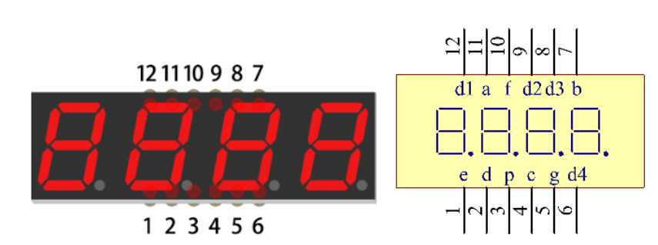

Breadboard setup: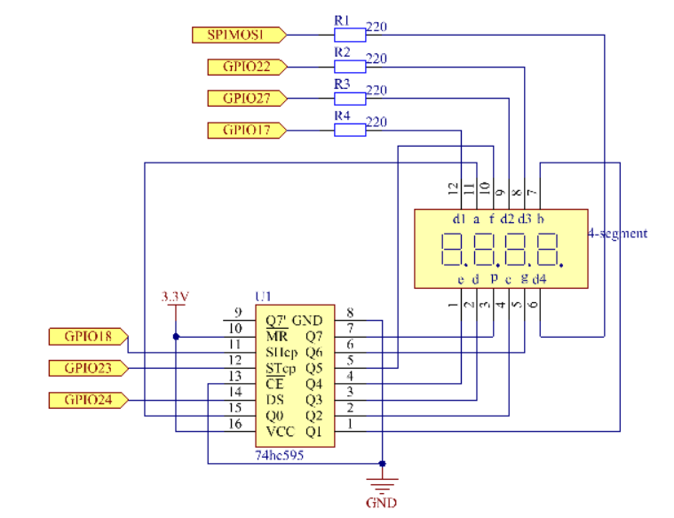

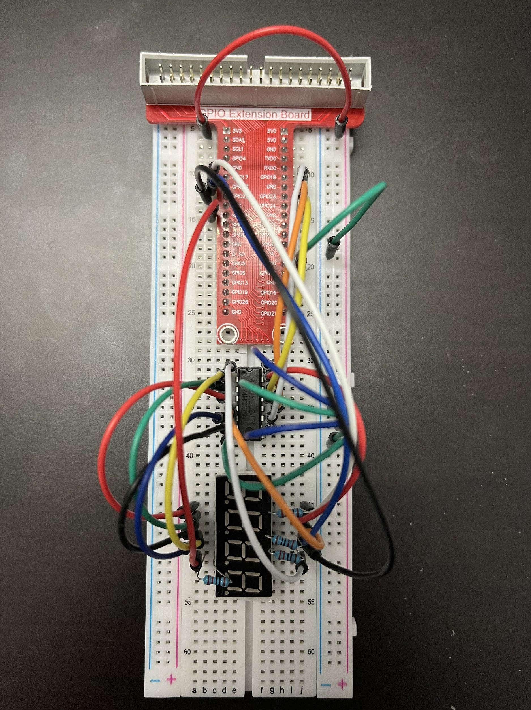

We have the code 1 as OFF and 0 as ON for the 7-segment display

The display follows the following format: (DP)GFEDCBA

We have the following display:

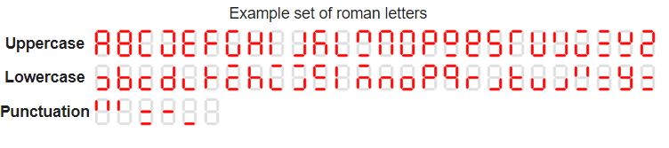

Thus, the sentence “hi you did good job” can be changed to the following hex text



Source code: <https://github.com/MynameisKoi/CE450L/blob/main/Midterm/midterm.py>

import RPi.GPIO as GPIO

import time

import threading

from sys import version_info

if version_info.major == 3:

raw_input = input

SDI = 24

RCLK = 23

SRCLK = 18

placePin = (10, 22, 27, 17)

text = (0x8b, 0xcf, 0xff, 0x91, 0xa3, 0xe3, 0xff, 0xa1, 0xcf, 0xa1,

0xff, 0xc2, 0xa3, 0xa3, 0xa1, 0xff, 0xe1, 0xa3, 0x83, 0xff)

counter = 0

timer1 = 0

def clearDisplay():

for i in range(8):

GPIO.output(SDI, 1)

GPIO.output(SRCLK, GPIO.HIGH)

GPIO.output(SRCLK, GPIO.LOW)

GPIO.output(RCLK, GPIO.HIGH)

GPIO.output(RCLK, GPIO.LOW)

def hc595_shift(*data*):

for i in range(8):

GPIO.output(SDI, 0x80 & (*data* << i))

GPIO.output(SRCLK, GPIO.HIGH)

GPIO.output(SRCLK, GPIO.LOW)

GPIO.output(RCLK, GPIO.HIGH)

GPIO.output(RCLK, GPIO.LOW)

def print_msg():

print ("========================================")

print ("| Display 'hi you did good job' |")

print ("| ------------------------------ |")

print ("| SDI connect to GPIO24 |")

print ("| RCLK connect to GPIO23 |")

print ("| SRCLK connect to GPIO18 |")

print ("| |")

print ("| Control 7-seg display with 74HC595 |")

print ("| |")

print ("| SunFounder|")

print ("========================================")

print ("Program is running...")

print ("Please press Ctrl+C to end the program...")

raw_input ("Press Enter to begin\n")

def pickDigit(*digit*):

for i in placePin:

GPIO.output(i,GPIO.LOW)

GPIO.output(placePin[*digit*], GPIO.HIGH)

def timer():

global counter

global timer1

timer1 = threading.Timer(0.2, timer)

timer1.start()

print("%d" % counter)

if counter > 22:

counter = 1

else:

counter += 1

def main():

global counter

print_msg()

global timer1

timer1 = threading.Timer(0.2, timer)

timer1.start()

while True:

if counter < 19:

clearDisplay()

pickDigit(0)

hc595_shift(text[counter])

if counter > 0 and counter < 20:

clearDisplay()

pickDigit(1)

hc595_shift(text[counter-1])

if counter > 1 and counter < 21:

clearDisplay()

pickDigit(2)

hc595_shift(text[counter-2])

if counter > 2 and counter < 22:

clearDisplay()

pickDigit(3)

hc595_shift(text[counter-3])

def setup():

GPIO.setmode(GPIO.BCM)

GPIO.setup(SDI, GPIO.OUT)

GPIO.setup(RCLK, GPIO.OUT)

GPIO.setup(SRCLK, GPIO.OUT)

for i in placePin:

GPIO.setup(i, GPIO.OUT)

def destroy(): # When "Ctrl+C" is pressed, the function is executed.

global timer1

GPIO.cleanup()

timer1.cancel() # cancel the timer

if __name__ == '__main__':

setup()

try:

main()

#except IndexError:

# destroy()

except KeyboardInterrupt:

destroy()

Run program & demonstration:

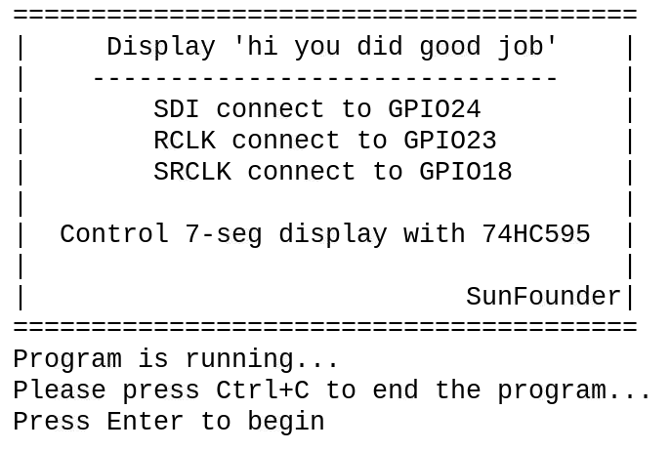

Video link: <https://youtu.be/A9KefSkz3vk>